**MOTORCYCLE INDUSTRY IN INDIA**

**By –**

1. **Rushang Phira(E011)**
2. **Tarran Pidugu(E012)**
3. **Alok Rajpurohit(E014)**
4. **Aniket Raman(E015)**
5. **Vaishnavi Rathod(E016)**

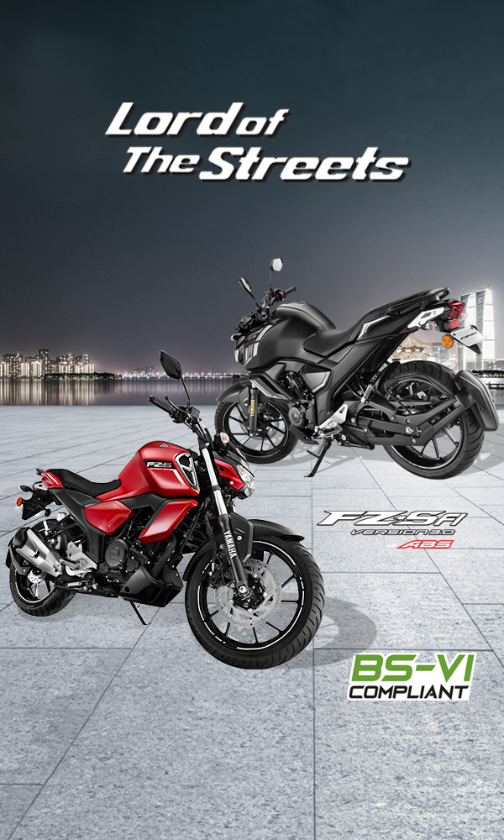

**Table of Contents**

|  |  |  |  |
| --- | --- | --- | --- |
| **SR.NO.** | **TITLE** | **PAGE NO.** | **REMARKS** |
| 1. | Introduction | 3 |  |
| 2. | Case Study 1 – Hero MotoCorp | 5 |  |
| 3. | Case Study 2 – Bajaj Auto | 10 |  |
| 4. | Case Study 3 – Honda Motor | 16 |  |
| 5. | Case Study 4 – Royal Enfield | 23 |  |
| 6. | Case Study 5 – Yamaha Motor | 27 |  |
| 7. | Conclusion | 33 |  |

**Introduction**

### **Market Trend**

Motorcycle sales in India skyrocketed over the past few years, making the country the biggest motorcycle market in the [**World**](https://motorcyclesdata.com/2018/12/26/world-motorcycles-market/) overtaking China since the 2016 and achieving a record volume of 22.4 million units (including commercial three-wheeler) in the 2018.

During the 2012-2018 period over 124 million of new bikes have been sold in the country with annual increase of 8 million units, a too fast growth for a country with still poor urban and extra-urban infrastructures.

Starting from the last quarter 2018 the market is showing a downward trend and with the last, thirteenth consecutive month of fall are counted.

The 2019 was quite negative losing near 3 million units from the previous year with final sales at 19.1 million units (-14.4%), at the third all-time best level.

Please note that within these data there are the two-wheelers, bot ICE and Electric, and three-wheelers (rickshaw).

The **electric scooter segment** for which the Government just raised a target to grow at 20 millions units in the next 5 years, dropped over 40%. To understand more, please read the dedicated [**report**](https://motorcyclesdata.com/2019/09/21/indian-electric-scooter-and-motorcycles-market/).

Several factors causing the slowdown, including an increase in insurance premium in 2018 and the new BS-VI emission norms taking effect in April 2020. This led experts to suggest people were waiting for the discounts on BS-IV models and for more BS-VI-compliant models to land in the showrooms. However, the price of BS-VI model could be higher than the current.

So, while other observers forecast the sales to continue slipping for a few more months and to bounce back up once the new emission standards are introduced. we are more negative, considering the impact of expected new regulations necessary to shift the manufacturers focus toward the government 2025 target of 90% electric vehicles production and sales.

**Competitive Arena**

India’s four biggest motorcycle manufacturers posted lower sales numbers in 2019 than they did in 2018 confirming they all have lost momentum.

The market leader, [Hero,](https://motorcyclesdata.com/2018/12/03/hero-motor/) ended the year with 6.78 million sales, losing 1.1 million units from the previous year record. The arch-rival, Honda sold 4.9 million two-wheeler, losing 16.7% or 1 million units, while the third, [**TVS**](https://motorcyclesdata.com/2019/03/08/tvs-motor/) reported 2.82 million sales (including rickshaw), down 8.9% after having closed the first half in positive territory.

In fourth place [Bajaj Auto](https://motorcyclesdata.com/2018/11/14/bajaj-auto/) with 2.55 million motorcycles and rickshaw sold, down 7.8%. In our Database the **KTM** models produced in India by Bajaj are not included in these figures, but reported separately under KTM brand (which improved 27%).

In fifth place, **Suzuki** gained two position establishing the new record in this market with 707.468 sales, up a remarkable 12.5%

Behind, [**Royal Enfield**](https://motorcyclesdata.com/2019/03/16/royal-enfield/) with 693.000 sales (-18.0%) followed by **Yamaha** with 659.000 (-16.9%) and **Piaggio** with 189.362 (-9.8%).

Looking at premium brands, the leader is **KTM** (locally produced and distributed by Bajaj) with 57.768 sales, up 27%.

**BMW** keeps booming, after the July 2018 local plant opening and ranks as 11th with 4.600 units.

**Case Studies**

Our team has picked 5 companies from the Indian Motorcycle Market to present case studies on them. These companies include-

1. Hero MotoCorp – Aniket Raman
2. Bajaj Auto – Alok Rajpurohit
3. Honda Motor – Vaishnavi Rathod
4. Royal Enfield – Rushang Phira
5. Yamaha Motor – Tarran Pidugu

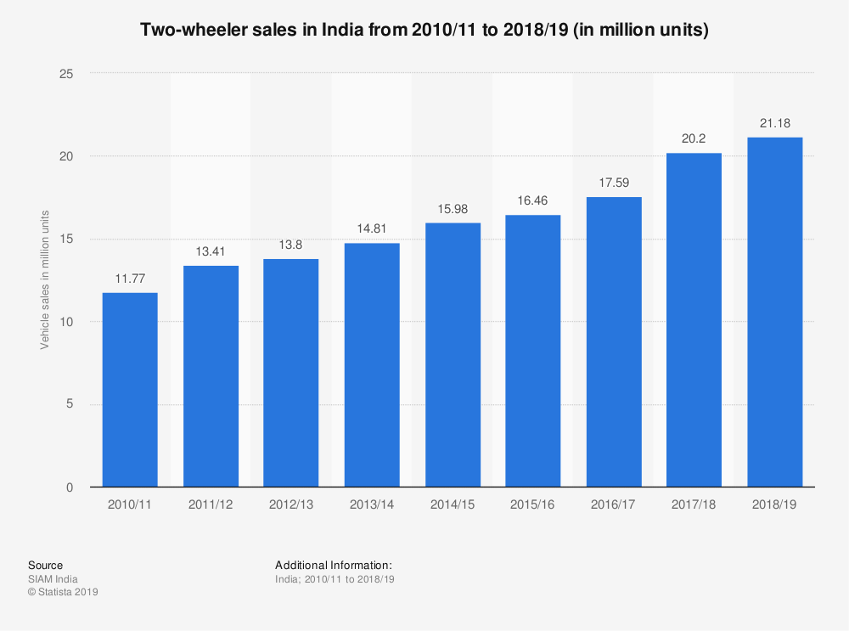

**Hero MotoCorp Ltd – Case Study**

**Introduction**

Hero MotoCorp Ltd. (HERO) is India's leading two-wheeler company. Based out of New Delhi, it manufactures motorcycle & scooter which has been providing customers with an excellent range of two wheelers and is setting benchmarks in style & comfort, performance and technology

**History**

HERO started its operations in 1984 as a joint venture between Hero Cycles (Munjal family) of India and Honda of Japan.It introduced motorcycles that were popular in India for their fuel economy and low cost. A popular advertising campaign based on the slogan 'Fill it – Shut it – Forget it' that emphasised the motorcycle's fuel efficiency helped the company grow at a double-digit pace since inception. In 2001, the company became the second largest two-wheeler manufacturing company in India and globally.  Under the joint venture with Honda, Hero Group could not export to international markets. In 2010, Honda decided to move out of the joint venture due to differences between the two partners. The company was renamed Hero Motocorp Ltd. Today it is the largest and best bike manufacturer in India & the world. The technology in the bikes of HERO for almost 26 years (1984–2010) has come from the Japanese counterpart Honda.

**Why Two-wheelers are important in the Indian context:**

More than half of all miles travelled in India are on two-wheelers which is expected to rise. It is expected that 90% of Indian households will have a two-wheeler by 2030. It is projected that India's two-wheeler fleet will double from 165mn in 2018 to 327mn by 2030. Some important statistics is given below in *Exhibit 1.*

Exhibit 1

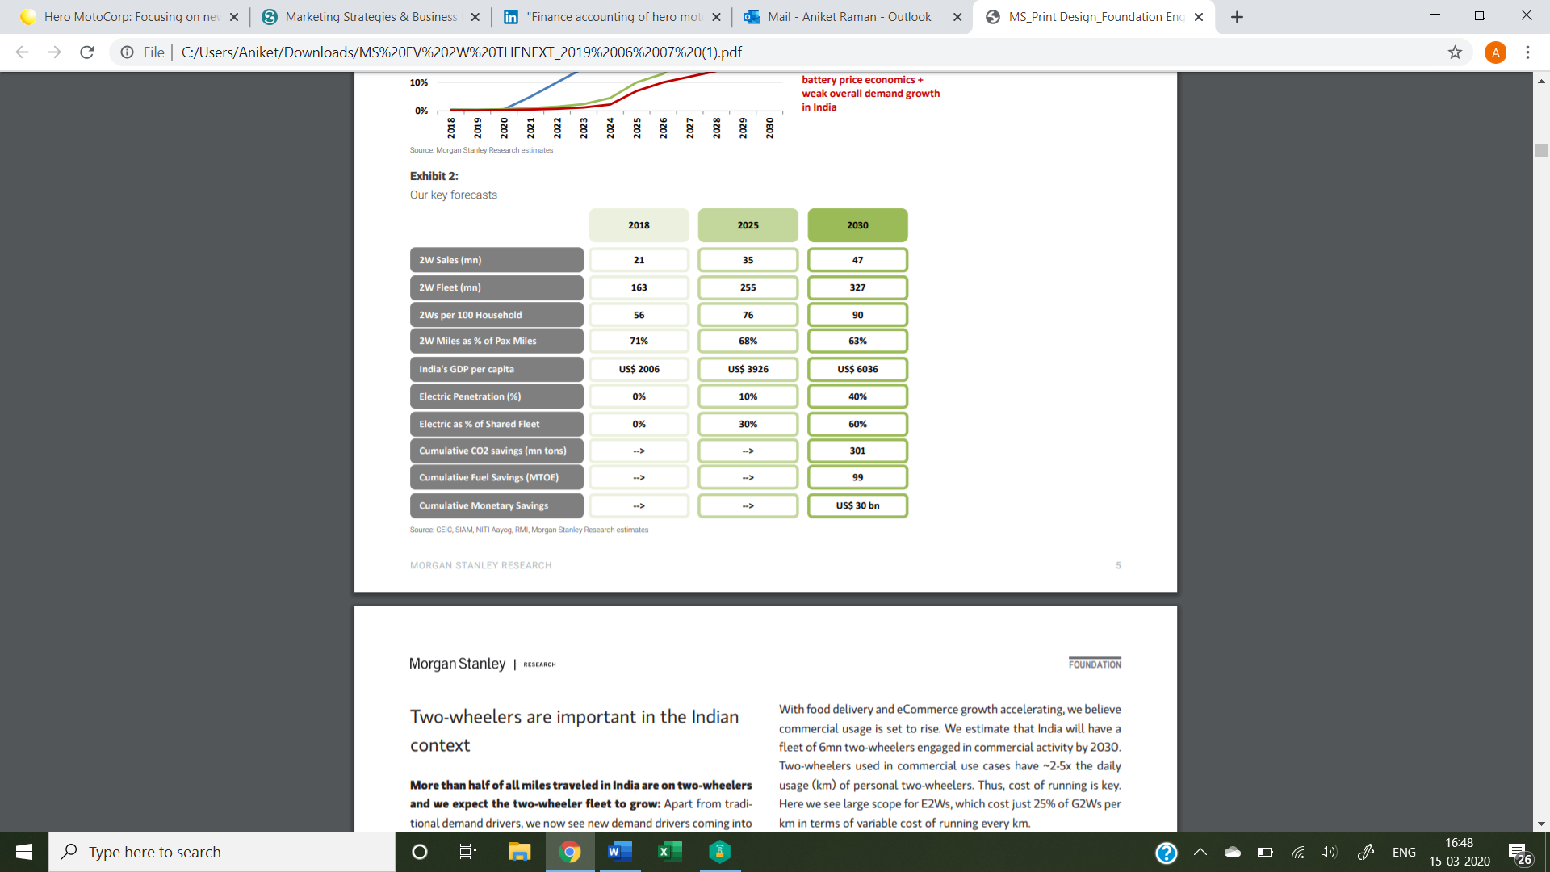

The graph in *Exhibit 2* shows the breakup of the percentage of various vehicles on Indian roads including 2 wheelers (2W), 3 wheelers (3W), Personal Vehicles (PV) & Commercial Vehicles (CV). It is interesting to note that more than 50% of the roads is filled with 2W.

Exhibit 2

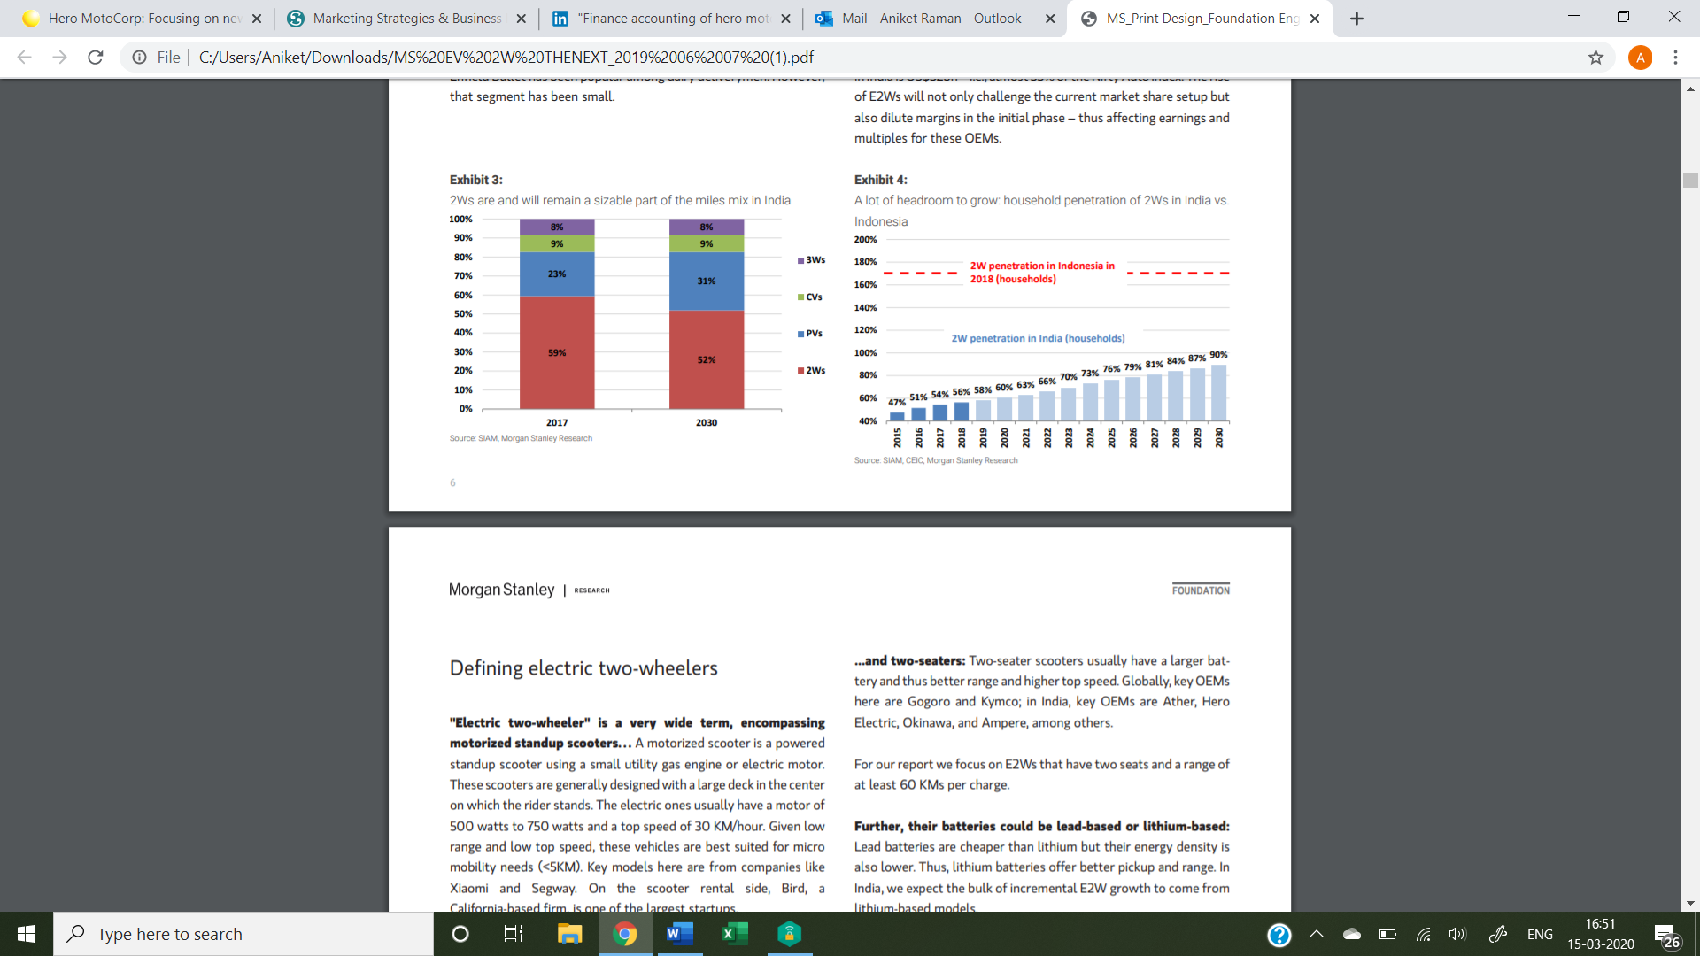

In the graph in *Exhibit 3* we note the following:

* About 50% of two wheelers bought are motorcycles with a capacity of <125 cc. This is because of its relative low cost coupled with high mileage This sufficed the middle-class workers who used 2W to commute.
* Motorcycles >125 cc like Royal Enfield account for about 15%.
* There has been a ‘scooterization’ as the fleet of scooters in 2011 was 17% which has grown to 32% now. The nuclear family is preferring scooters over bike since it is unisex.

Exhibit 3

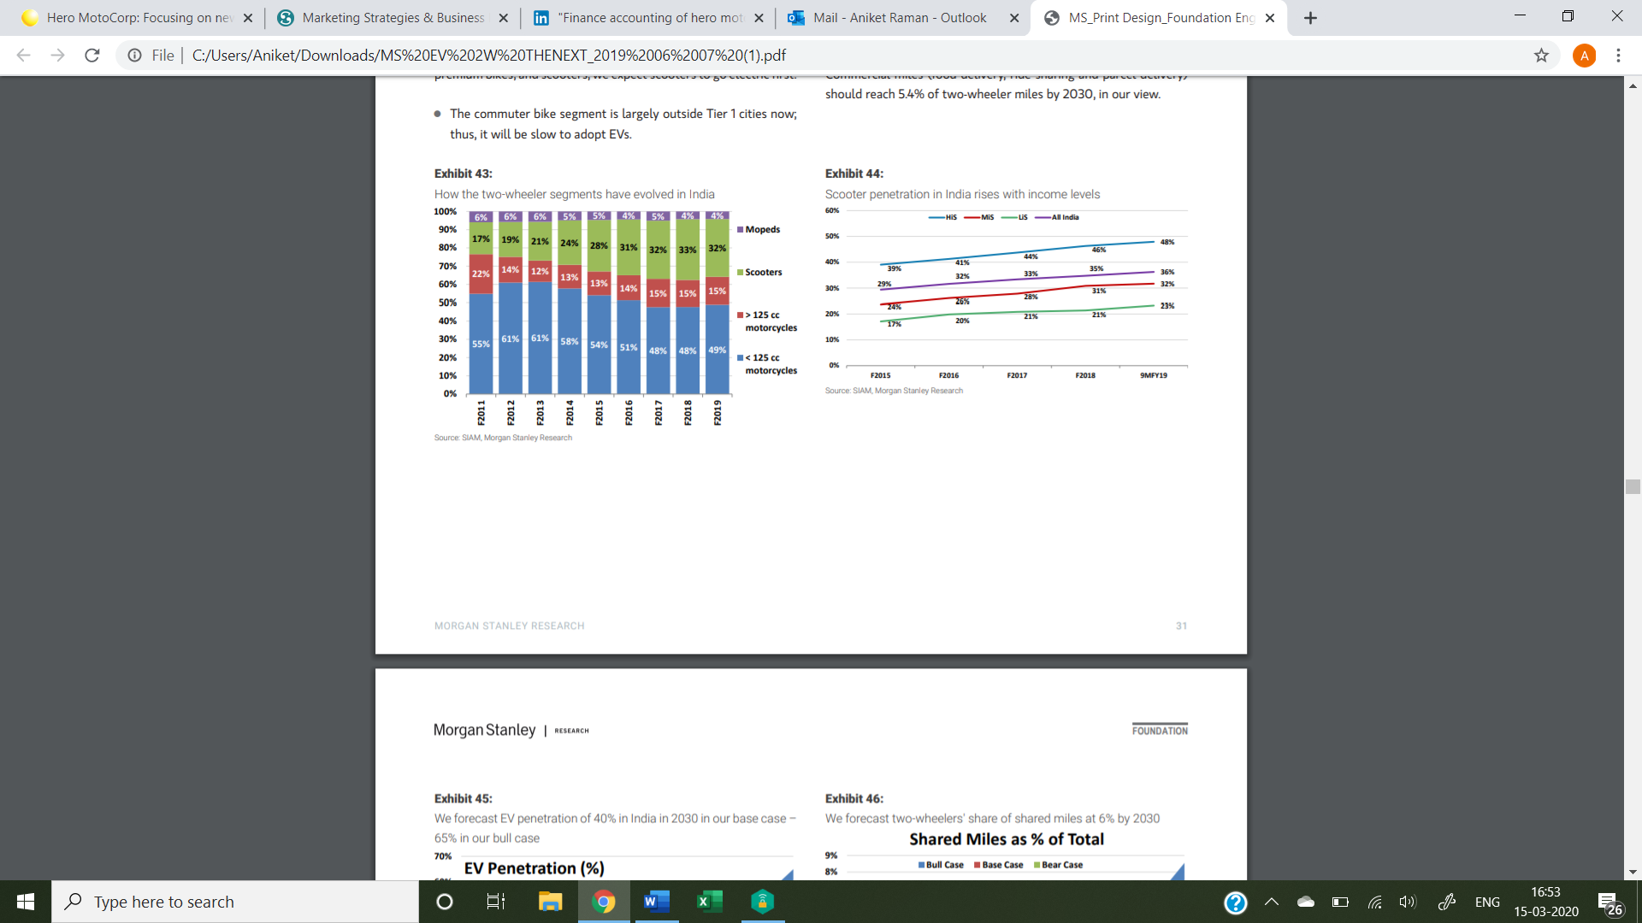

Exhibit 4

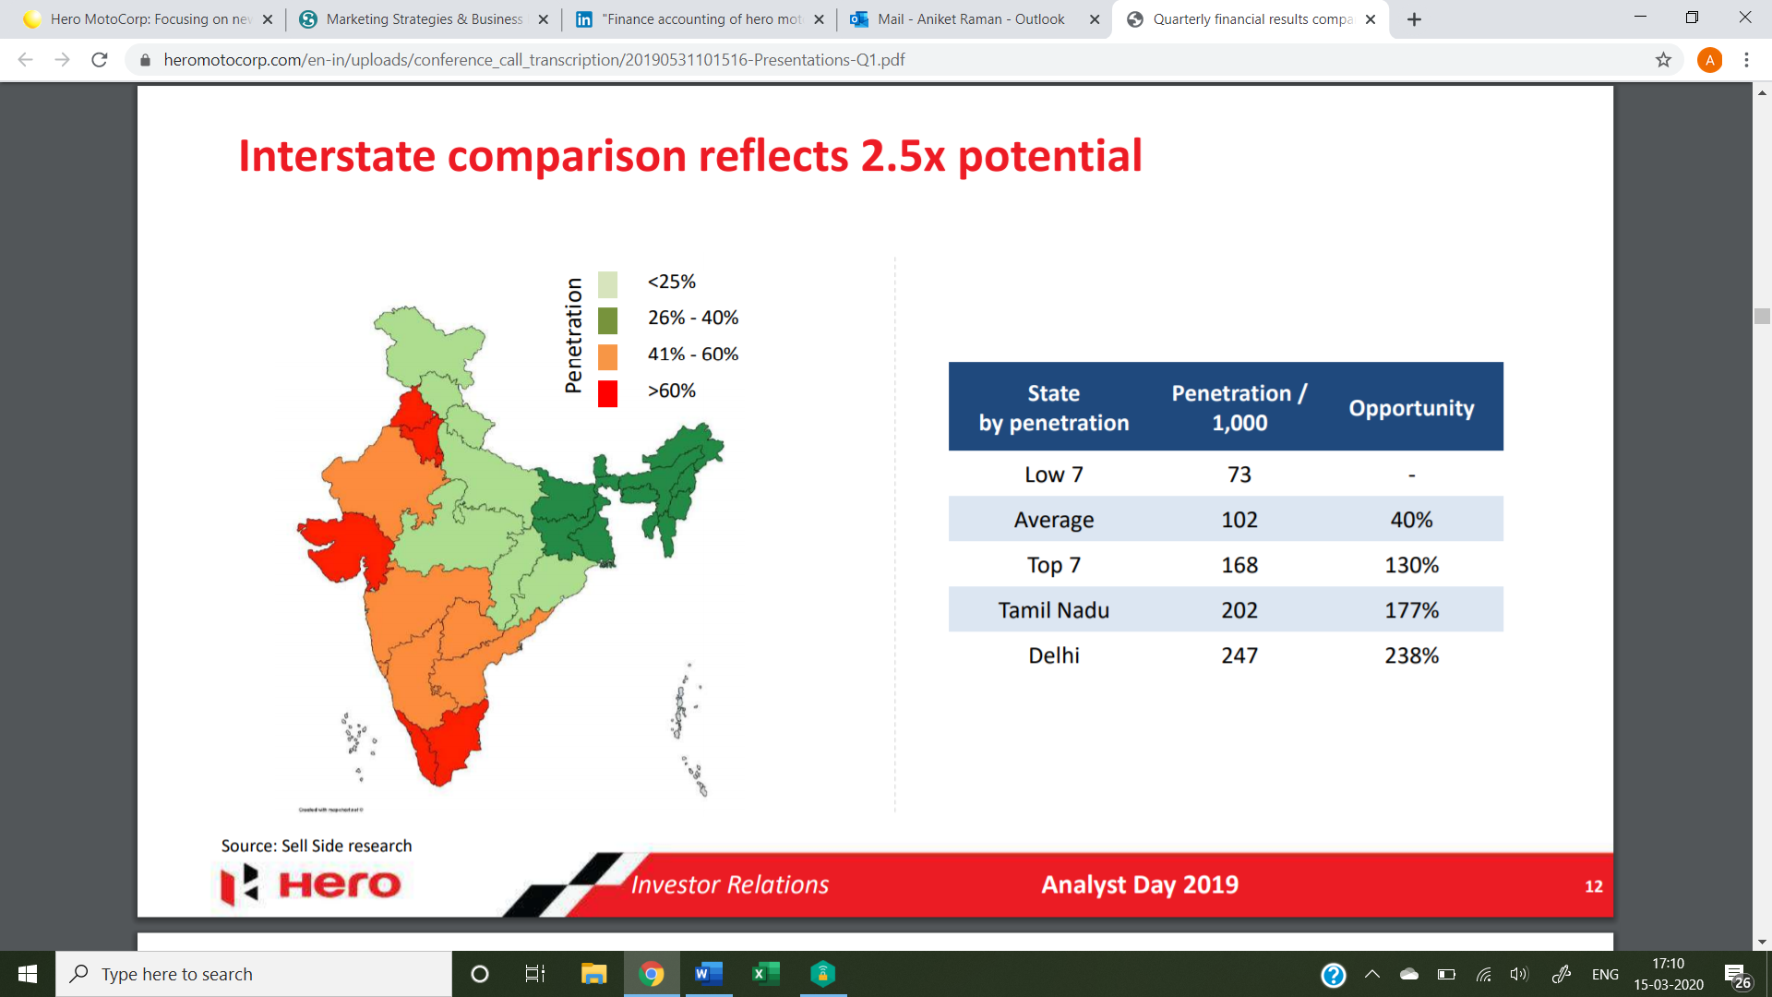

Exhibit 4 shows the penetration % i.e. the number of people in the respective states who own a bike. The richer/more developed states have over 60% of people who own a bike. Meanwhile states in Northern/Central India have less than 25% people who own a bike. Hence Hero saw opportunities in such states to expand and to increase the penetration percentages in these states.

Hero has sensed that two-wheeler (2W) demand is only going to increase because of the following reasons:

* Bikes used for catering/ food delivery companies: Food delivery and the food carrying/delivering industry like Zomato/Swiggy/Scootsy is growing at a rapid rate. All of these companies use 2 wheelers to service customers.
* Point to point mobility: What 4 wheelers do not achieve that 2 wheelers do is allowing users to get to an exact location/very close to it allowing for limited (if any) walking.
* Aspirational youth and women prefer 2 wheelers: People with age 20-30 prefer two wheelers. As do women who travel for work, school etc.

As of 2019, 4 of the top 5 selling 2W brands are Hero brand viz. Splendour, HF, Passion, Glamour. A reason for this is Hero has by far, the most number of touchpoints in the country, i.e the most number of bike stations/showrooms in the country (around 6600).

Hence, for people living in rural areas, chances are that a Hero showroom is much closer than any other showroom. Hence, they would rather buy a Hero bike than any other. This is applicable for urban areas as well.

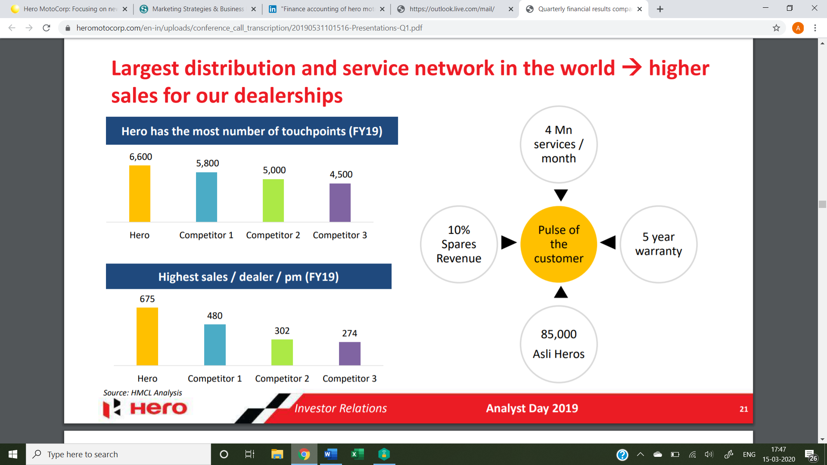

**Hero and its brands**

SPLENDOUR: Splendour is the model that has sold 3.2 million bikes until 2019 which is by far the most of any brand of any company in India. It has an engine displacement of 97.2 cc. It also has a high mileage of 80.6 kmpl which significantly higher than other bike models. It is an air-cooled commuter bike which costs around Rs 50K. The models include Splendour, Splendour+, Super Splendour, Splendour NXG, Splendour Pro 2012 among others. Hero saw this as a good opportunity to introduce the model Splendour which comes under the <125 cc category. No one has really been able to overthrow Splendour as the most sold bike model in India. The advertisement campaigns such as FILL IT, SHUT IT, FORGET IT and YAARANA MEELON KA were to emphasize how Splendour had a tremendously high mileage.

HF: HF is a model which has sold 2.2 million bikes as of 2019. It is the bike model which has sold the 2nd most number of bikes after Splendour. It has also got a displacement engine of 97 cc as well as a mileage only slightly lesser than Splendour. It is the cheapest model at < Rs 40k.

PASSION: A model which has sold 0.9 million bikes as of 2019.

GLAMOUR: It is a model which has sold 0.8 million bikes until 2019.

Passion & Glamour are among the top 5 models of bikes sold in India. The top end Hero bike models include KARIZMA, CBZ EXTREME, HUNK etc. The most expensive Hero motorcycle is XPulse 200 priced at Rs 1.15 Lakh.

**Focus on spare parts business**

Hero initiated “Fight Fake, Stay Safe” campaign against the manufacturers and traders of spurious parts and counterfeit products. There are about 25k seized parts under 200k labels. To counter this challenge, Hero has 226 authorized parts distributor outlets and 20,450 retail points where Hero genuine parts are sold. In addition, HMCL runs ‘Asli Hero’ program for parts distributors in India and Unique Product Identifier (UPI) authentication campaign.

**How Hero increased its global footprint**

HERO today has global presence in Latin America (Columbia, Argentina), South Asia ( Nepal, Bangaldesh, Sri Lanka), Africa, Middle east (Turkey, Iran etc) and targets to expand to 50 countries by 2020.

Steps it took to help in globalisation of the brand

* Hero has 7 factories including one in Bangladesh and one in Colombia.
* It is the only 2W manufacturer to offer 4-year warranty on all its models in Colombia.
* It participates in various international motor shows including those held in Milan, Dhaka, Colombo to showcase its 2W
* It has built is brand abroad by sponsoring various international sporting events including Hero MotoSports Team Rally, Hero Caribbean Premier League. It is an associate sponsor of BANGLADESH cricket team. It appointed Argentinian football legend Diego Simeone as brand ambassador. In soccer, HMCL was the national supporter for the FIFA U-17 World Cup India 2017
* It has R&D centres in 5 countries incl. Germany & UK

**Proactive Measures taken to increase market share**

* Increasing focus on electric 2W - As can be seen in the statistics in Exhibit 1, the Electric 2W are set to increase from zilch in 2018 to 10% in 2025 to 40% in 2040. In keeping with its vision of being “future ready”, in addition to its own internal electric vehicle program, Hero has acquired 30% stake in Ather Energy, a start-up focused on developing, designing and selling premium electric scooters.
* Hero is been launching BS-VI compliant products well before the proposed timeline of 2020.

**Conclusion**

As per Hero’s Company website it is the no. 1 two-wheeler manufacturer, with 34 years of experience, having sold over 90 million two wheelers. Hero MotoCorp is a success story of corporate India due to its great vision and execution.

**Bajaj Auto Pvt. Ltd. – Case Study**

**Introduction**

Bajaj Auto Limited is an [Indian](https://en.wikipedia.org/wiki/List_of_companies_of_India) global two-wheeler company and three-wheeler manufacturing company based in [Pune, Maharashtra](https://en.wikipedia.org/wiki/Pune,_Maharashtra).[[2]](https://en.wikipedia.org/wiki/Bajaj_Auto#cite_note-2) It manufactures [motorcycles](https://en.wikipedia.org/wiki/Motorcycles), [scooters](https://en.wikipedia.org/wiki/Scooter_(motorcycle)) and [auto rickshaws](https://en.wikipedia.org/wiki/Auto_rickshaw). Bajaj Auto is a part of the [Bajaj Group](https://en.wikipedia.org/wiki/Bajaj_Group). It was founded by [Jamnalal Bajaj](https://en.wikipedia.org/wiki/Jamnalal_Bajaj" \o "Jamnalal Bajaj) in [Rajasthan](https://en.wikipedia.org/wiki/Rajasthan) in the 1940s. It is based in [Pune](https://en.wikipedia.org/wiki/Pune), [Maharashtra](https://en.wikipedia.org/wiki/Maharashtra), with plants in [Chakan](https://en.wikipedia.org/wiki/Chakan,_Maharashtra) ([Pune](https://en.wikipedia.org/wiki/Pune)), Waluj (near [Aurangabad](https://en.wikipedia.org/wiki/Aurangabad,_Maharashtra)) and [Pantnagar](https://en.wikipedia.org/wiki/Pantnagar" \o "Pantnagar) in [Uttarakhand](https://en.wikipedia.org/wiki/Uttarakhand).[[3]](https://en.wikipedia.org/wiki/Bajaj_Auto#cite_note-Forbes-3) The oldest plant at [Akurdi](https://en.wikipedia.org/wiki/Akurdi,_Mawal" \o "Akurdi, Mawal) ([Pune](https://en.wikipedia.org/wiki/Pune)) now houses the [R&D](https://en.wikipedia.org/wiki/Research_and_development) centre 'Ahead'.

Bajaj Auto is the world's third-largest manufacturer of motorcycles and the second-largest in [India](https://en.wikipedia.org/wiki/India).[[4]](https://en.wikipedia.org/wiki/Bajaj_Auto#cite_note-4) It is the world's largest three-wheeler manufacturer.[[5]](https://en.wikipedia.org/wiki/Bajaj_Auto#cite_note-5)

On May 2015, its [market capitalisation](https://en.wikipedia.org/wiki/Market_capitalisation) was [₹](https://en.wikipedia.org/wiki/%E2%82%B9)64,000 [crore](https://en.wikipedia.org/wiki/Crore) (US$9.0 billion),making it [India](https://en.wikipedia.org/wiki/India)'s 23rd largest publicly traded company by [market value](https://en.wikipedia.org/wiki/Market_value).[[6]](https://en.wikipedia.org/wiki/Bajaj_Auto#cite_note-6) The [Forbes Global 2000](https://en.wikipedia.org/wiki/Forbes_Global_2000) list for the year 2012 ranked Bajaj Auto at 1,416.

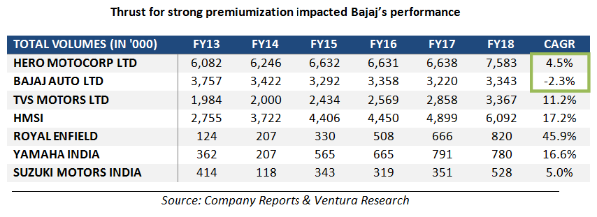

**Brief History**

Founded in the 1940’s Bajaj Auto was a consolidated part the Bajaj group of companies, but also diversified into various manufacturing activities.

Rahul Bajaj, took charge of the business in 1965. Under his leadership, the turnover of the Bajaj Auto the flagship company has gone up from INR.72 million to INR. 120 billion, its product portfolio has expanded and the brand has found a global market.

In 2005, Rahul Bajaj's son Rajiv Bajaj stepped into the shoes of Managing Director of Bajaj Auto and steered the organization to becoming a global automobile behemoth. He introduced the Pulsar range of bikes, that revolutionised the two-wheeler market in India.

In 2007, Bajaj Auto acquired a 14% stake in KTM that has since grown to 48%. This partnership catalysed Bajaj Auto’s endeavour to democratise motorcycle racing in India. Bajaj Auto today exclusively manufactures Duke range of KTM bikes and exports them worldwide. In FY2018, KTM was the fastest growing motorcycle brand in the country

In 2017 it was announced that Bajaj Auto and [Triumph Motorcycles Ltd](https://en.wikipedia.org/wiki/Triumph_Motorcycles_Ltd) would form an alliance to build mid-capacity motorcycles.[[10]](https://en.wikipedia.org/wiki/Bajaj_Auto#cite_note-10)

26 November 2019 Bajaj Auto invested $8 million (approx. [₹](https://en.wikipedia.org/wiki/%E2%82%B9)57 [crore](https://en.wikipedia.org/wiki/Crore)) in bicycle and electric scooter rental startup Yulu.

## Importance of Motorcycle Industry in Indian Market

The motorcycle segment constitutes about 81.5% of the two-wheeler market in India*1*. It also contributes to three-fourths of the total exports in the two-wheeler industry. Bajaj is the second largest company in this segment of the Indian market after Hero MotoCorp.

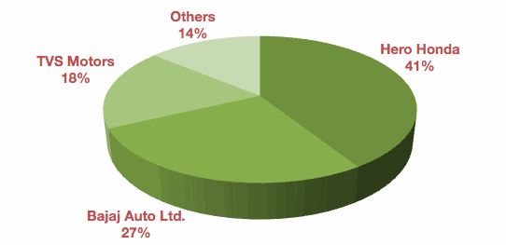

## Reasons for growth

### **Personal Income-**

Demand increases as the income increases, only to be substituted later by the demand for four wheelers. Income has been steadily growing in India and is projected to stabilise at a growth rate of 9-12 percent range by 2012*2*.

### **Demography and Inspiration-**

The bigger the young and working population, the greater is its need for commutation. The IT and BPO revolution have influenced this movement. This is a favourable factor since India’s workforce is young.

### **Penetration Level-**

The lower the penetration levels in the market, the better the scope for future demand. As the penetration of the rural market is significantly low, it is going to be a significant long term growth driver.

### **Other Factors-**

Improvement in infrastructure increases competition, while simultaneously improving the public transport. The average time period taken to replace an existing bike with a newer model has decreased from 7 years to 5 years, resulting in replacement demand growth.

## Problems in the Two-Wheeler Industry - Negative Growth

Analysis of the different segments leads us to the conclusion that the main reason for negative growth in the two-wheeler market is the fall in demand for the 100-cc segment which has traditionally enjoyed the maximum market share.

|  |  |  |  |  |  |
| --- | --- | --- | --- | --- | --- |
|  | *FY06* | *9M/07* | *Q4/07* | *Q1/08* | *Q2/08* |
| Motorcycles | 19% | 18% | 4% | -10% | -12% |
| 100cc | 7% | 14% | -12% | -20% | -23% |
| 125cc | 121% | 31% | 71% | 10% | 11% |
| 150cc | 29% | 22% | 43% | 28% | 22% |

Many factors have contributed to this phenomenon. A few of them are discussed ahead.

#### Increasing Loan Interest Rates

#### Credit Crunch

#### Increasing Oil Prices

#### Launch of Low-Priced Cars Like Tata Nano

#### Tightening Regulations (Emission Standards)

## Positioning of Bajaj Auto in the Two-Wheeler Industry

Bajaj Auto is the flagship company of the Bajaj Group of Companies. Bajaj Auto Limited (BAL) is currently India's second largest two-wheeler manufacturer. The core competency of Bajaj Auto Ltd is its technology and innovation. Both DTS-i (Digital Twin Spark Ignition) and DTS-Fi (Digital Twin Spark Fuel Ignition) are technological breakthroughs by Bajaj. BAL is also a pioneer in product innovation having introduced technologies such as ExhausTEC (Exhaust Torque Expansion Chamber), LED Tail Lamps, LCD Display, SNS, Spare parts (Tubeless tyres, rear disc brakes), Black colour scheme etc.

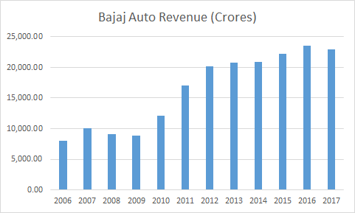

**Segmentation, targeting, positioning in the Marketing strategy of Bajaj Auto**

The Company segments the population on the basis of characteristics like age, gender, income group, region, family size, social class, price sensitivity, loyalty, expectations, personality attributes, and [lifestyle](https://www.marketing91.com/vals-values-attitude-lifestyle/). Bajaj Auto uses a mix of [demographic](https://www.marketing91.com/demographic-segmentation/) and [geographic](https://www.marketing91.com/geographic-segmentation-segmenting-geography/) [segmentation strategy](https://www.marketing91.com/segmentation-strategy/). This is because the distribution of this [product](https://www.marketing91.com/what-is-a-product/) matters a lot. The same way, demographic points like Earning of the [individual](https://www.marketing91.com/individual-marketing/) also matters.

Differentiating [targeting](https://www.marketing91.com/how-to-make-a-targeting-strategy/) [strategy](https://www.marketing91.com/marketing-and-strategy-models-and-concepts/) is used by the company to be competitively ahead of its competitors and [target](https://www.marketing91.com/swot-analysis-target/) the customer group with the distinctive features of the offerings. Pulsar is one clear such model where it has differentiated itself with its combination of design and power throughout the market.

## ****Competitive advantage of the Marketing strategy of Bajaj Auto****

**Subsidiaries & Joint Ventures -** The Company not only have an operation in India but it operates in other parts of the world which helps the company in being competitively ahead of its competitors. PT. Bajaj Auto Indonesia, a subsidiary of Bajaj Auto with 99.25% share and Bajaj Auto [International](https://www.marketing91.com/international-marketing/) Holdings BV, Netherlands (BAIH BV) is 100% subsidiary of Bajaj Auto Ltd. These subsidiaries are involved in primarily manufacturing KTM range of motorcycles.

**Renowned Indian Conglomerate -**It is one of the 25 companies of the Bajaj Group which have more than 75 years of existence and have a presence in diverse businesses such as Electronics, Life Insurance, General Insurance, financial services and other businesses.

**Well Established**[brand](https://www.marketing91.com/what-is-a-brand/) - The brand is well known and loved by the [People](https://www.marketing91.com/people-marketing-mix/) of India from where it originates. There are models present in the Bajaj Auto Product [portfolio](https://www.marketing91.com/product-portfolio/) which are very well known and adopted across the country and several parts of the globe.

## ****Distribution strategy in the Marketing strategy of Bajaj Auto****

The company uses a mix of different channels of distribution for its different business segments such as for Bajaj Motorcycle and commercial vehicle segment it uses authorized distributors for sales & service, company-owned sales & service outlets, DSA ( direct selling agents) and [e-commerce](https://www.marketing91.com/e-commerce-segmentation/) sites. While for KTM motorcycle business vertical it distributes its offerings through distributors and e-commerce sites.

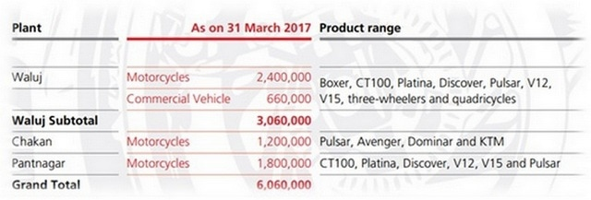

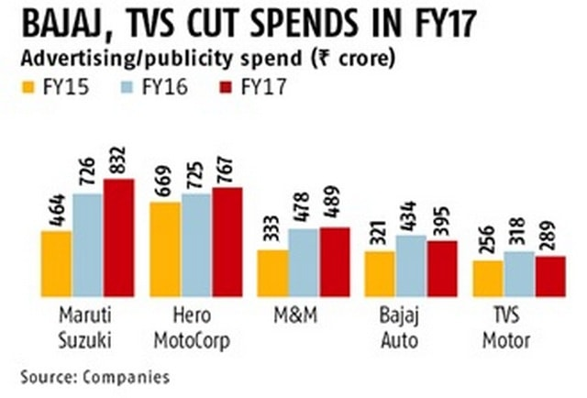

## ****Competitive analysis of the Marketing strategy of Bajaj Auto****

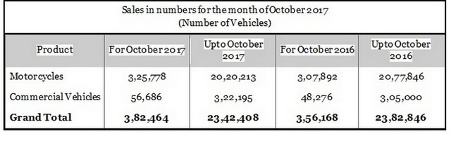

## ****Customer analysis in the Marketing strategy of Bajaj Auto****

Customers of Bajaj Auto range from travel enthusiasts to transporters, to auto drivers, racers, and students. Customers are divided into passenger vehicles segment customers and commercial vehicle segment customer. Passenger segment customers are in the age group of 20-40 years while in commercial vehicle segment there are [retail customers](https://www.marketing91.com/9-lessons-from-a-retail-business/) and [B2B](https://www.marketing91.com/business-to-business-marketing/) customers like transporters who use it for its own business.

**Recent Performance**

[Bajaj Auto Ltd](https://www.livemint.com/market/mark-to-market/investors-impressed-with-bajaj-auto-s-market-share-gains-need-to-count-costs-1555381441750.html) has made a heroic comeback in the domestic [motorcycle market](https://www.livemint.com/market/mark-to-market/bajaj-auto-realizations-hit-the-skids-dragging-profits-in-december-quarter-1548875922134.html). The company has steadily increased its market share to 20% in the fourth quarter of FY19, after sliding to a low of 14% seven quarters ago. In doing so, it has given incumbents such as Hero MotoCorp Ltd and Honda Motorcycle and Scooters India Pvt. Ltd a run for their money. Market share of the two companies fell by 100 basis points (bps) and 550 bps, respectively, during the period.

Bajaj Auto’s two-wheeler sales rose by 4.8% year-on-year in April. To be sure, it had grown in double digits for several months in FY2018. Sales of Hero and Honda contracted by 17% and 33%, respectively, in April, continuing the decelerating trend in sales.

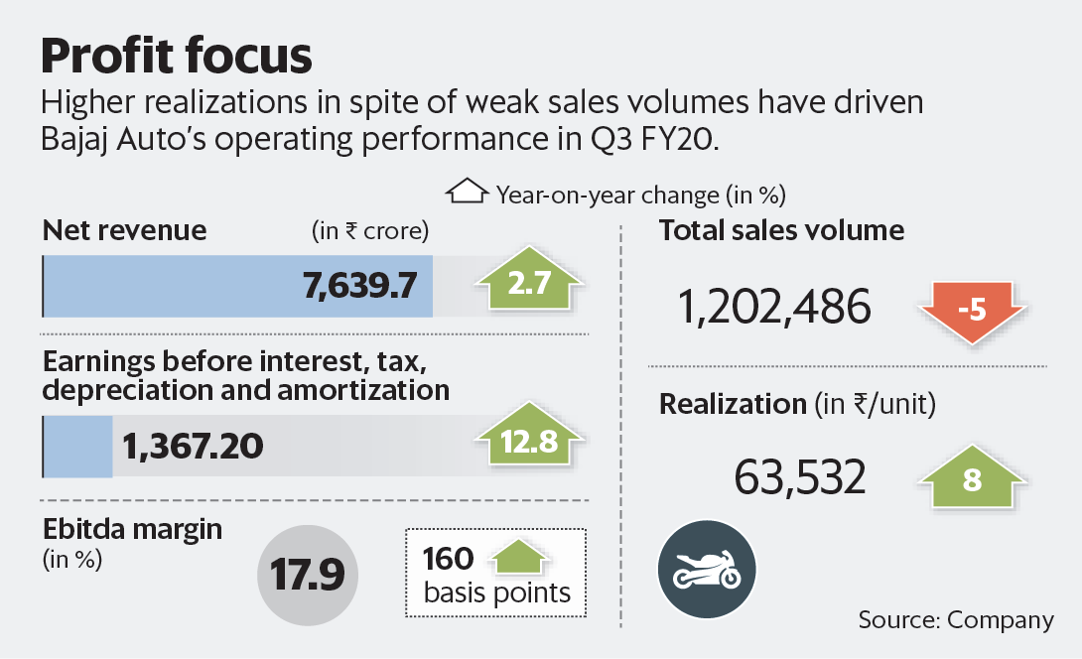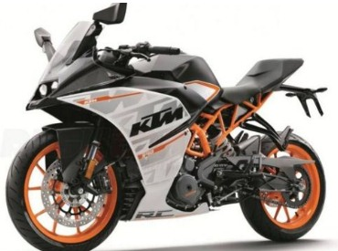

## 

## The Way Ahead

### **Graduating Customers from the 100cc to Higher Segments**

There are several reasons why Bajaj should concentrate on its core segment, i.e. greater than 125cc segment. With the introduction of DTS-i and DTS-Fi technology, Bajaj Auto Limited has led the way in pioneering technology along with style.

The Profitability Pyramid in Exhibit 4 shows that the margin is very low in the sub-125cc segment but volumes are high. BAL wants to shift users from 100, 115cc segment to 125cc and higher. Thus, Bajaj not only wants to play on the margins but also wants to increase the market share of 125cc bikes. With its recent launch of XCD 125cc, it has brought in competition for its own 100cc model, Platina by delivering a bike that is better in all respects (including fuel efficiency).

### **Scaling Up Service Centres**

Bajaj Auto plans to expand its service centres both in numbers and in capacity. Keeping in line with its growth target for the next 5 years.

### **Focus on Easy Credit Lending**

### **Investment in Research and Development**

**Performance in global market**

**Bajaj Auto** in the 2019 pushed the brake in the global expansion, due to the lost of 12% in the domestic sales in India. Global sales had been 3.6 million, down 0.2 million from the previous year. The growth in several markets, including CIS region and east Europe and the gain of share in Latin America allowed to contain the lost in a negative market environment.

In Latin America and Asia, Bajaj is leader in several countries. Despite the market declined, the manufacturer was able to keep 2019 sales steady, gaining market share. In Countries like Indonesia and Brazil Bajaj Auto is the one of the highest sold Motorcycle brands.

**Conclusion**

Bajaj is the first Indian two-wheeler manufacturer to deliver 4-stroke commuter motorcycles with sporty performance for the Indian market, which was otherwise dominated mostly by mileage-based products from Hero and TVS Motors. Bajaj achieved this with the 150cc and 180cc Pulsar, giving Indians the first taste of performance biking. This was also accompanied by innovative marketing techniques - by featuring its flagship product Pulsar 220 DTS-i in Pulsar MTV Stuntmania, India's first stunt biking reality show. It is the second highest sold motorcycle brands in India, owning about 27 percent of the Indian Market. This makes Bajaj Auto one of the largest companies in the two-wheeler sector of the market both domestically and globally.

**Bibliography**

* https://www.bajajauto.com/
* <https://en.wikipedia.org/wiki/Bajaj_Auto>
* <https://www.marketing91.com/marketing-strategy-bajaj-auto/>
* <https://economictimes.indiatimes.com/industry/auto/>

**HONDA MOTOR COMPANY LTD.(HMC) – Case Study**

**Introduction:**

Honda motor company, ltd is a Japanese public multinational conglomerate corporation primarily known as manufacturer of automobiles ,motorcycles , and power equipment. Honda is the world’s largest manufacturer of two wheelers , recognized all over the world as the symbol of Honda two wheelers , the ‘Wings’ arrived in India as Honda Motorcycle and Scooter India Pvt. Ltd.(HMSI),a 100% subsidiary of Honda Motor Company Ltd. Japan, in 1999. Despite being one of the youngest players in the Indian two-wheelers market, Honda has become the largest two wheeler manufacturer as well as the second largest two-wheelers company in India. In 2017,India became the largest motorcycle market of Honda. In India, Honda is leading in the scooters segment with 59% market share.The total investment outlay for the initial capacity was Rs. 215 crores and now the accumulated investment is 800 crores.

HMSI has revolutionized the multi-dimensional Indian two-wheeler market with products like Activa, Twister ,Dio, Aviator, Unicorn, Shine, Dazzle ,Stunner and Dream Yuga. In its 18 years’ journey, Honda 2Wheelers India has won more than 120 prestigious awards. It is also awarded with the most trusted two-wheeler brand by Brand Equity.

**Vision:**

“*Serve people worldwide with the joy of expanding their life’s potential*.” Lead the advancement of mobility and enable people everywhere in the world to improve their daily lives. This is the vision of Honda.

HMSI is committed to build a sustainable business with strong social relevance and a commitment to inclusive growth and contribute to the society by supporting causes on various concerns including road safety, healthcare, environmental sustainability, promoting education, promoting sports and other rural developmental activities. In pursuance to the vision that HMSI desires to be a ‘Company which society wants to exist’, it is dedicated towards fulfilling the social objectives through various CSR activities. The company shall make its endeavor to positively impact and influence the society for its sustainable development.

**Business Policies:**

Value proposition – To provide products and services that expand people’s dreams and potential.

Corporate proposition – Their approach is to take new challenges while being driven by a strong passion to realize the value proposition.

**Philosophy:**

Everyone has a dream that gives their life deeper meaning and sparks passion. When we pursue our dreams, we feel empowered. Honda encourages all its associates to pursue their dreams. That’s why they say they are a company built on dreams. The power of Honda’s dream will continue to lead to new insights and technologies in motorcycles and other fields of mobility. And Honda will spread the philosophy of the Power of Dreams in India. A country where a billion people carry dreams in their hearts, this philosophy is brought alive by “Sach kar denge Sapne”.

In line with Honda’s philosophy HSMI conducts all its daily activities in pursuit of the following 3 joys:

* The joy of buying high quality products
* The joy of selling high quality products
* The joy of manufacturing high quality products

**Planning:**

* *Creating value for “mobility” and “daily lives”*

The focus is on three areas, namely mobility, robotics with AI and energy solutions in order to provide people with the joy and freedom of mobility and the joy of making their lives better.

* *Accommodate the different characteristics of people and society*

They strive to further expand the joy of people by offering products and services that are optimized based on Honda’s desire to “utilize technology to help people, while putting people at the core”

* *Towards a clean and safe/secure society*

They strive to become no.1 in the areas of environment and safety and will invest more resources in the area. They strive to become a company that leads the effort to realize a carbon-free and collision-free society.

**Products and their Marketing:**

* Honda Unicorn :Unicorn was introduced in 2004. It has 149.2 cc engine and top speed at 114 km/h. Honda unicorn 160 ad has been pictured beautifully to bring out the elegant appeal to CB Unicorn 160 and stressing the personality of the rider. The bike is a household name for performance and reliability in the 150-160 cc engine category. The bike is meant for individuals who are sincerely pursuing a sense of ‘stability’ in life with no compromise. In 2007 HMSI sold 720,000 unicorns and overtook Bajaj Pulsar to rank the highest in premium segment in the Motorcycle Total Consumer Satisfaction(MTCS) survey of 7,000 customers.
* Honda Shine: It is a 125 cc motorcycle launched in 2006. It is 5 gear bike and one of the best selling motorcycles in 125 cc segment. It is equipped with Honda Eco Technology(HET) engine which provides god balance of 10.7Ps power and 65 kmpl mileage. Honda launched a campaign “Kya shine hai!” for CB Shine. TVC aired on all the popular channels while the central theme of the ad was to celebrate the brand legacy.
* Honda Activa :Activa is the most popular and longest selling model of Honda launched in 1999 globally and 2001 in India.Honda began selling the cheaper and lighter version of Activa in 2013.In 2015 it was announced Honda had sold over 1 million Activa in 5 months in the Indian market that year. In 2014,The Economic Times reported Honda Activa was the best selling 2 wheeler in India outselling the Hero Splendor. Activa is responsible for 2,00,000 units sales each month.HMSI launched 360 degree campaign ‘A quiet revolution’ for its Activa 125 BSVI.It showcases the power of silence coming from Honda’s globally acclaimed Enhanced Smart Power(ESP) technology for a silent start and smooth eco-friendly ride. The campaign is conceptulised by Denstsu One, Akshay Kumar as the brand ambassador and also features his wife Twinkle Khanna.
* Honda Dio : The 100 cc scooter was launched in India in 2001 and has crossed 30 lakh sales milestone. In 2020,Honda revamped dio with Bharat Standard VI Emission regulations. It claims improvements in fuel efficiency and combined brakes.
* Honda Dream Yuga: It is a 109 cc single cylinder motorcycle launched in 2012. It is billed the least expensive Honda motorcycle currently produced. It comes with a more efficient HET engine. The TVC explored the very deep and loving bond of the mother with her son. The film ends with the brand ambassador Akshay Kumar revealing “Ek naya Yug, ek naya Dream”

**SWOT Analysis:**

*Strengths –*

1. One of the largest automobile manufacturers
2. Strong R&D departments and brand image
3. ISO certification on quality
4. Largest manufacturer of motor bikes
5. Strong marketing strategies
6. Quality with customer satisfaction

*Weaknesses-*

1. High cost structure/production price
2. Costly spare parts
3. Lack of advanced technology integration

*Opportunities –*

1. Great people with great skills
2. The increment in global presence
3. Introduction of eco friendly vehicles

*Threats –*

1. Increasing fuel prices
2. Intense competition
3. Alternative transportation

**Market Survey:**

Capital (as of March 31, 2019): 86 billion yen

Honda group companies: 435 affiliated companies in and out of Japan (as of March 31, 2019)

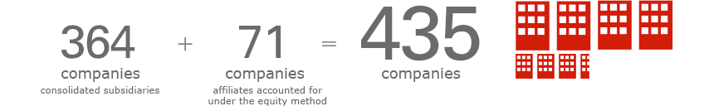

Consolidated financial results (for the fiscal year ended March 31, 2019)

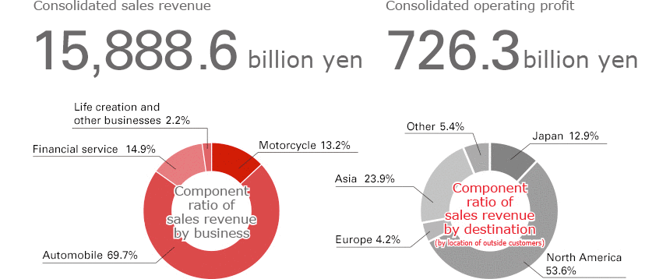

Status of shares (as of March 31, 2019)

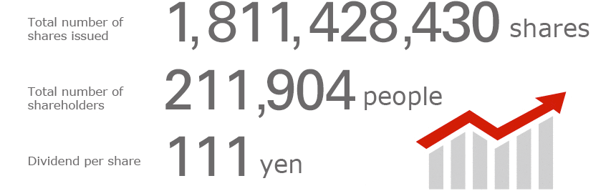

Worldwide unit sales for the fiscal year ended March 31, 2019  
(automobiles: through retail, motorcycles and power products: wholesale)

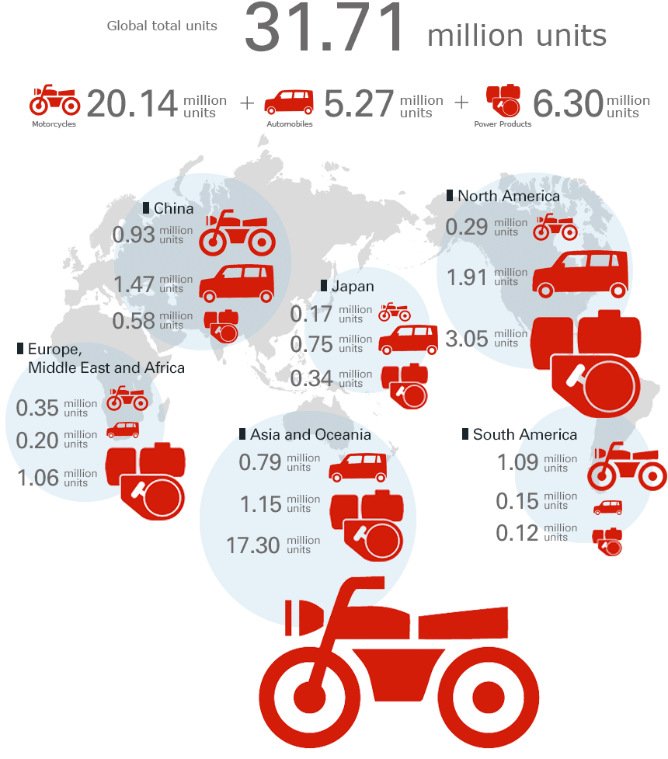

**Revenue:**

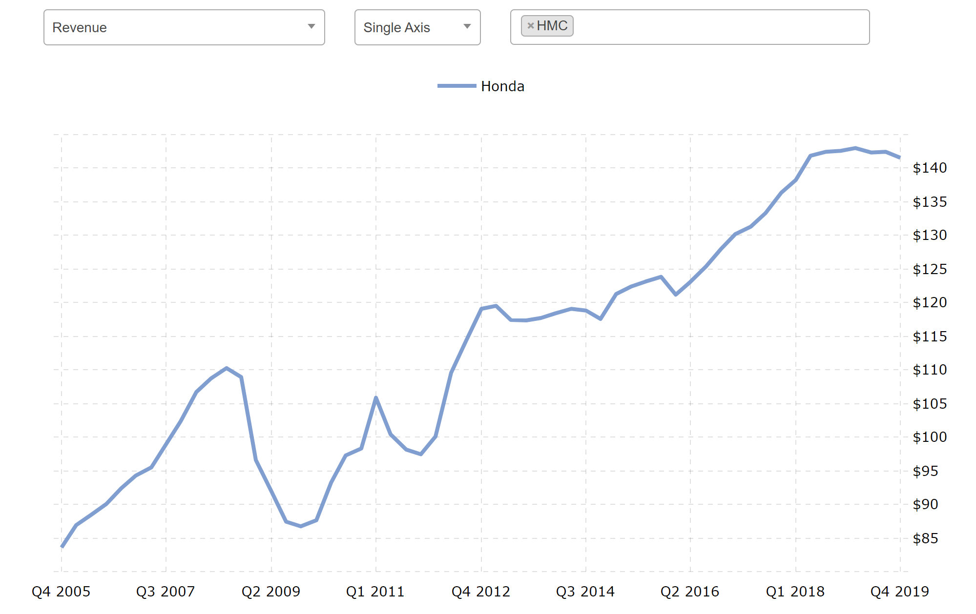

The data collected from 2005 to 2019 shows a gradual rise in the revenue generated by the brand. There is very noticeable fall in the revenue after the year 2009. But it picks up pace only to fall down again and finally rise around the year 2012.The highest revenue is seen during the year of 2018-2019.

**Gross profits:**

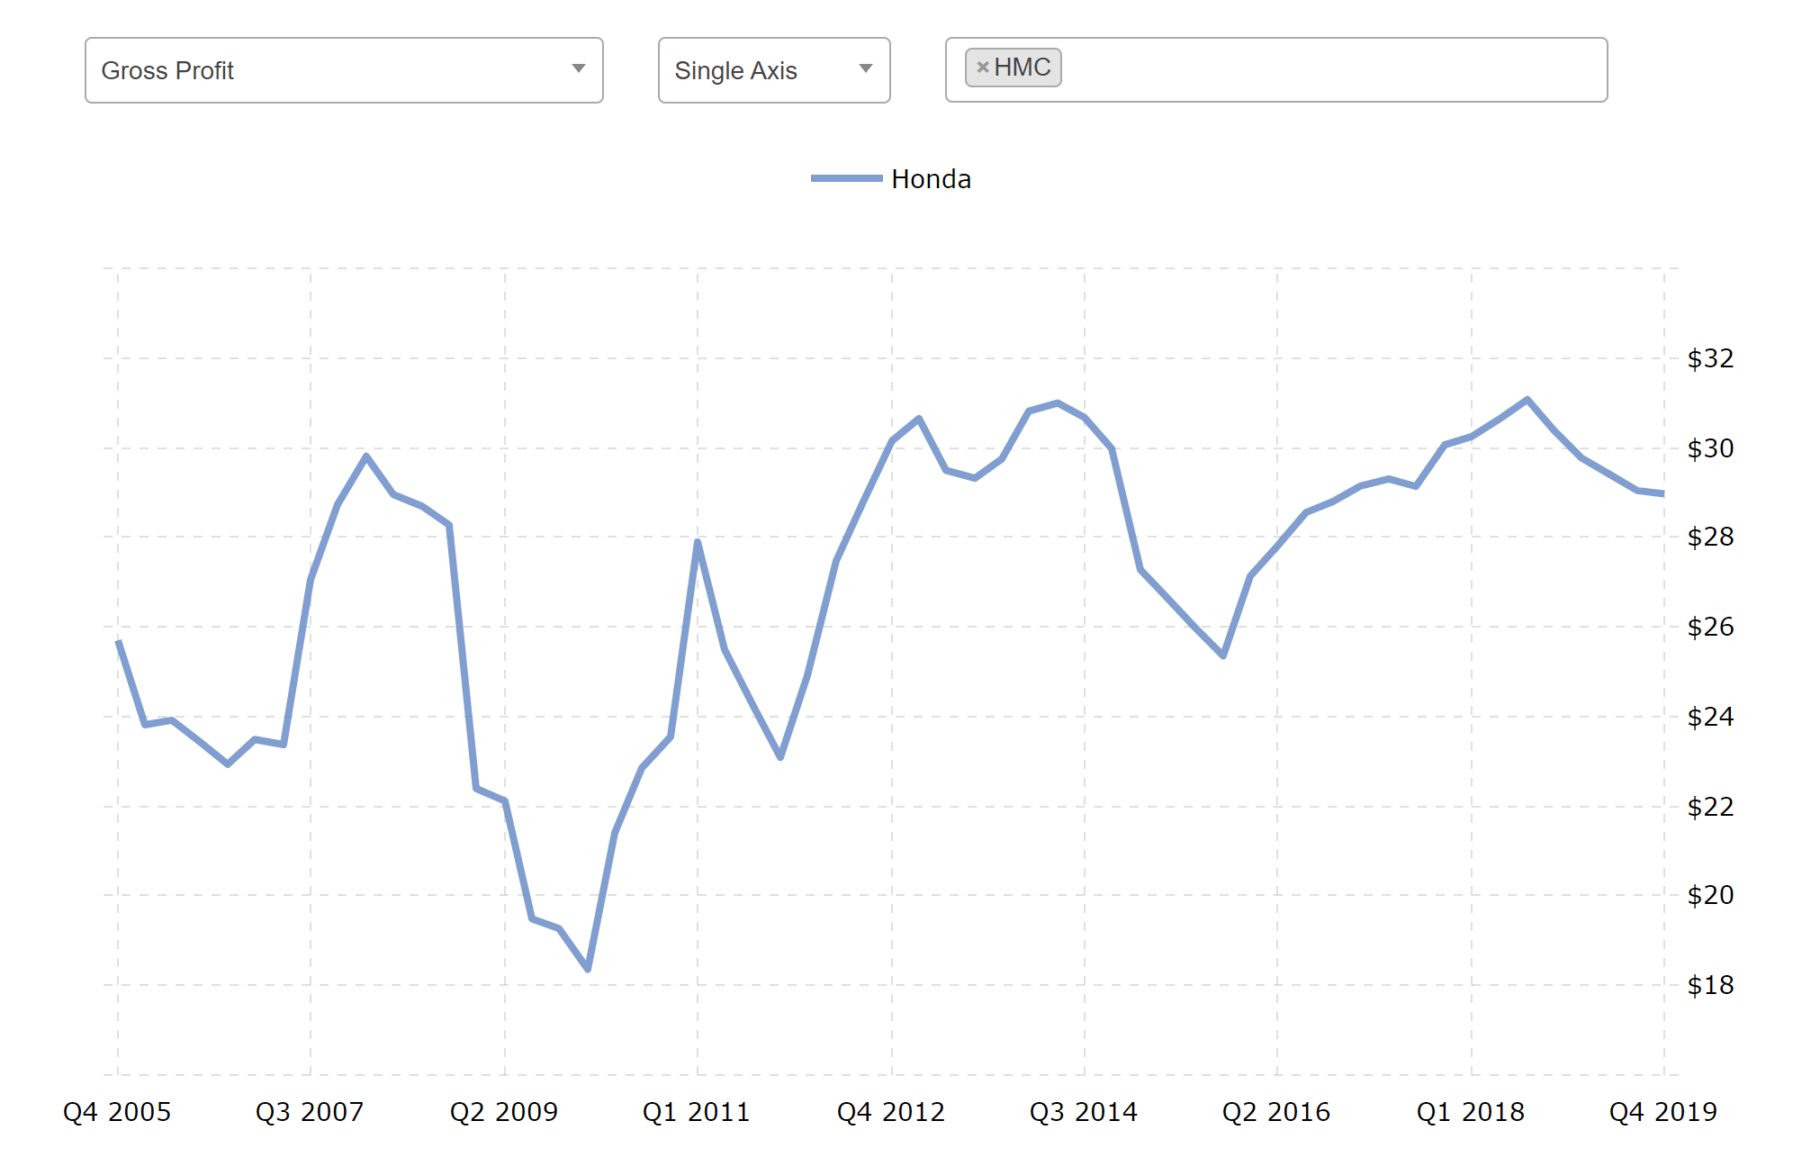

Over the years Honda has seen some very extreme figures in its gross profits. With the numbers fluctuating up and down almost yearly, the lowest is recorded in the year 2009-2010. 2019 is to a slow start but it hopefully picks up before the assessment of the next year.

**Net income:**

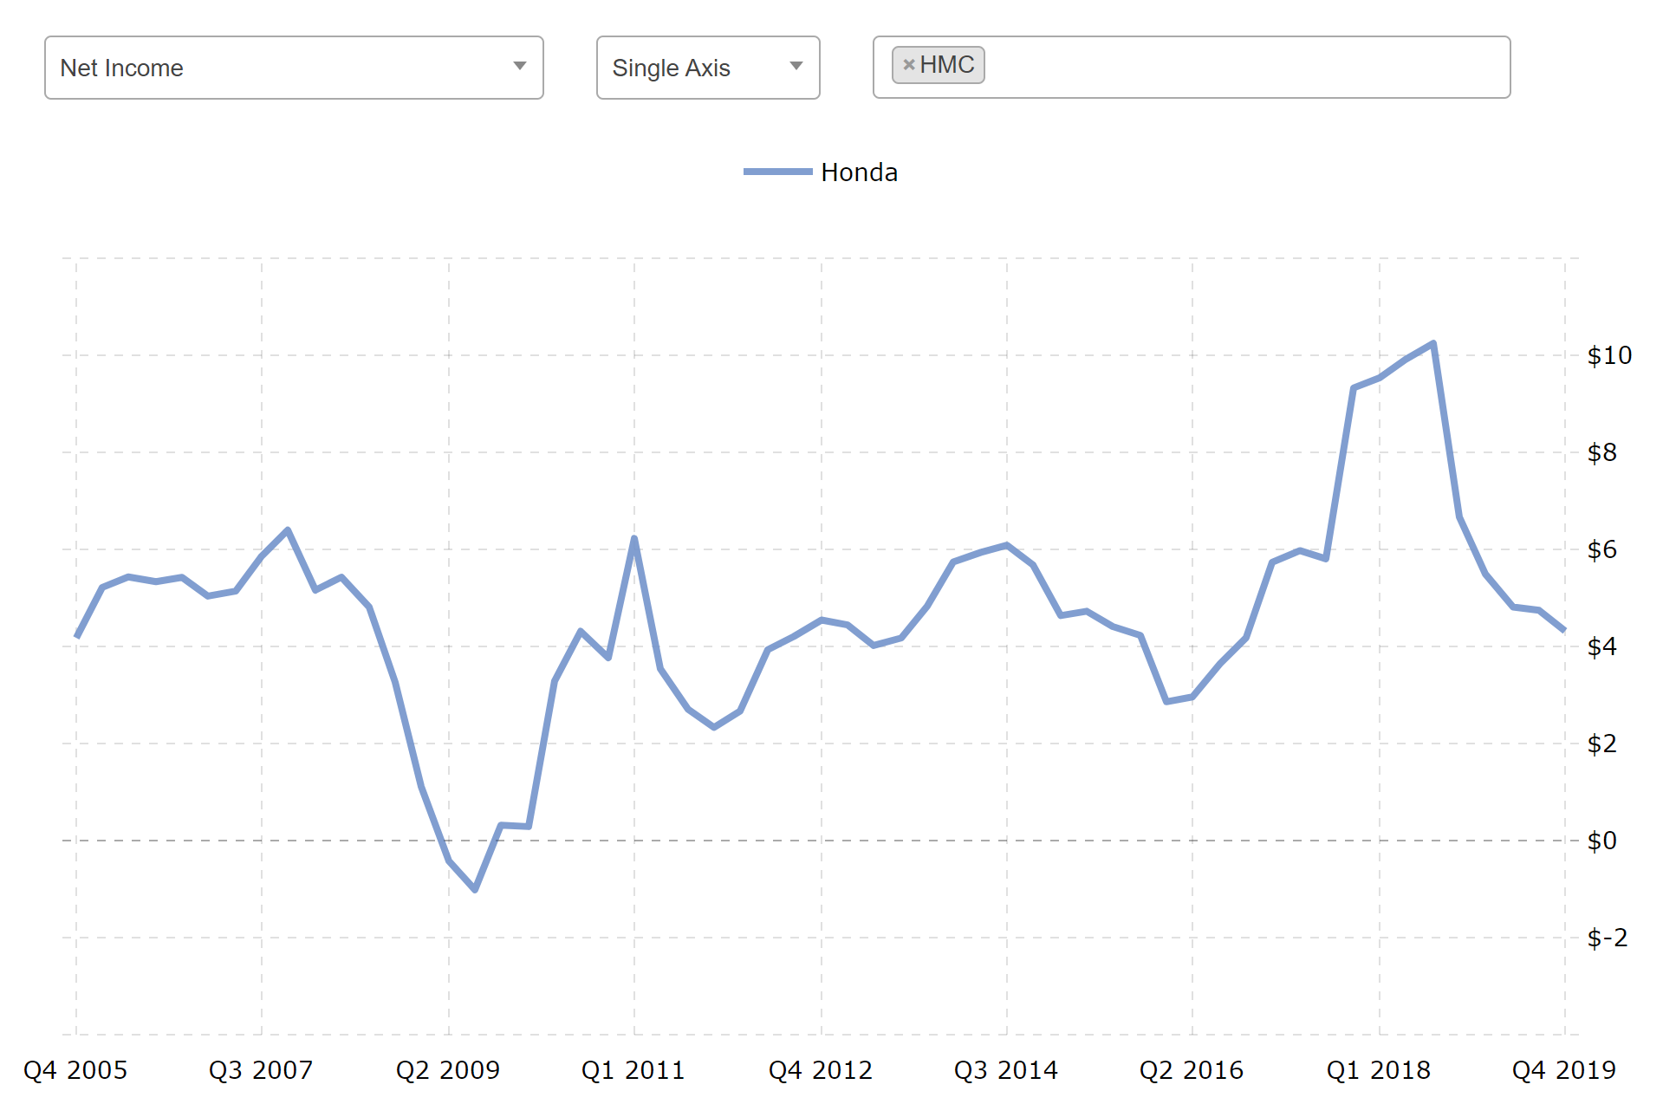

As is with all the other graphs, 2009-2010 proved to be a really poor year for Honda in a whole. The net income even stooped below the $0 line meaning the company went under loss. For the net income rate, 2018 saw a really great improvement in the numbers and looked promising in the market.

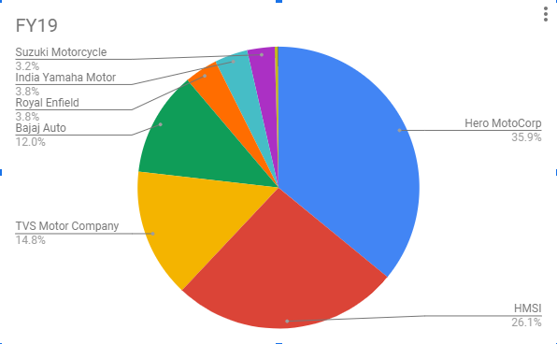

HMSI has sold 44,60,873 units in the first 11 months of FY2019 and is currently the No.2 player with 26.1% two-wheeler market share, announced it crossed the 550,000 unit BS VI compliant two-wheeler sales milestone. This was brought about by Activa 125, Activa 6G, Dio BS VI, SP 125, Shine, Unicorn. Yadvinder Singh Guleria, senior Vice President, Sales and Marketing commented, “The launch of BS VI models has provided Honda with a great momentum to leap ahead in the era”. Honda Activa is the country’s most sold scooter and company has also launched the Honda Grazia and Honda Cliq to cater to the younger audience.

**Honda 2Wheelers India: Total sales trend**

| Year | 2W industry | Honda 2Wheeler India sales | | |
| --- | --- | --- | --- | --- |
| ATSC | MC | Total |
| FY’2001-02 | 3,321,000 | 55,000 | 0 | 55,000 |
| FY’2002-03 | 5,053,000 | 166,300 | 0 | 166,300 |
| FY’2003-04 | 7,948,000 | 341,400 | 0 | 341,400 |
| FY’2004-05 | 6,576,000 | 486,150 | 64,950 | 551,100 |
| FY’2005-06 | 7,580,000 | 499,900 | 100,700 | 600,600 |
| FY’2006-07 | 8,482,000 | 546,700 | 168,600 | 715,300 |
| FY’2007-08 | 8,087,000 | 629,090 | 278,110 | 907,200 |
| FY’2008-09 | 8,481,000 | 666,450 | 403,750 | 1,070,200 |
| FY’2009-10 | 10,569,000 | 751,900 | 520,000 | 1,271,900 |
| FY’2010-11 | 13,397,606 | 907,421 | 750,632 | 1,658,053 |
| FY’2011-12 | 15,805,000 | 1,242,975 | 864,226 | 2,107,201 |
| FY’2012-13 | 15,811,405 | 1,462,918 | 1,291,666 | 2,754,584 |
| FY’2013-14 | 16,932,477 | 1,954,740 | 1,767,195 | 3,721,935 |
| FY’2014-15 | 18,462,178 | 2,580,161 | 1,872,134 | 4,452,295 |
| FY’2015-16 | 18,937,104 | 2,892,779 | 1,591,056 | 4,483,495 |
| FY’2016-17 | 19,909,100 | 3,097,358 | 1,910,745 | 5,008,230 |
| FY’2017-18 | 29,014,565 | 4,010,980 | 2,112,897 | 6,123,877 |
| FY’2018-19 | 24,462,231 | 3,910,070 | 1,990,599 | 5,900,669 |

2W- two wheelers, ATSC- automatic scooters, MC-motorcycles

**What makes Honda one of the world’s most innovative companies:**

* Don’t globalize ,localize. They combine engineering, design, and manufacturing in each of its large local facilities.
* Just as all major companies make use of robots to reduce costs and ease up the work, Honda believes in labor intensive work to maintain quality standard levels.
* Unlike other manufacturers, Honda can seamlessly produce multiple autos on a single assembly line one after the other and switch line over to a newly designed vehicle within hours.

**Conclusion:**

HMSI in January 2020 said it crossed the 25 lakh cumulative exports mark,19 years after commencing overseas shipments. They export 2wheelers to 26 countries in Asia, Middle East and Latin America. They are the leading scooter exporter in India and they aim to further consolidate its number 1 position in Honda’s global motorcycle business while unlocking the next chapter of exports growth in BS VI era.

**Bibliography:**

* [www.honda2wheelersindia.com](http://www.honda2wheelersindia.com)
* <https://global.honda/>
* <https://www.macrotrends.net/>
* [www.economictimes.com](http://www.economictimes.com)
* [www.businesswire.com](http://www.businesswire.com)
* [www.dnaindia.com](http://www.dnaindia.com)

**Royal Enfield – Case Study**

**Introduction**

Royal Enfield is the oldest motorcycle brand in continuous of production. It was founded in 1955 as a partnership between the Redditch based company and Madras Motors in India as “Enfield India”. The tooling was sold to Enfield India so that they could manufacture components.

Royal Enfield has defined its objective as disrupting the existing status-quo globally by creating a new category in motorcycling. Further it wishes to bring a fun and evocative motorcycling experience by focusing on midsize (250 cc to 750 cc) motorcycles. It also redefines motorcycling as a wholesome experience which means owning, riding, caring for as well as living with a motorcycle. These machines are simple, lasting and engaging. They are good for all occasions not only for city driving but also for various pursuits like touring, adventure and sporting. Overall, these machines are designed to give a complete experience of motorcycle and connect with its customer.

**Growth:**

Enfield’s business began when The Royal Enfield Bullet was chosen as a suitable motorcycle by the police and army for patrolling the country’s border. 800 350cc models were ordered by the government.

By 1962, all components which were either imported or partly manufactured in India, were being produced in India.

Since 1994, it is a subsidiary of Eicher Motors Limited.

In 2015, Enfield announced that it was establishing its North American headquarters in Milwaukee, Wisconsin.

Its parent company, Eicher, in August 2015, announced its foray in the international market by entry to Indonesia.

In April 2019, Royal Enfield announced its entry into South Korea, with Vintage Motors (Kiheung International) as its official distributor-partner in the country.

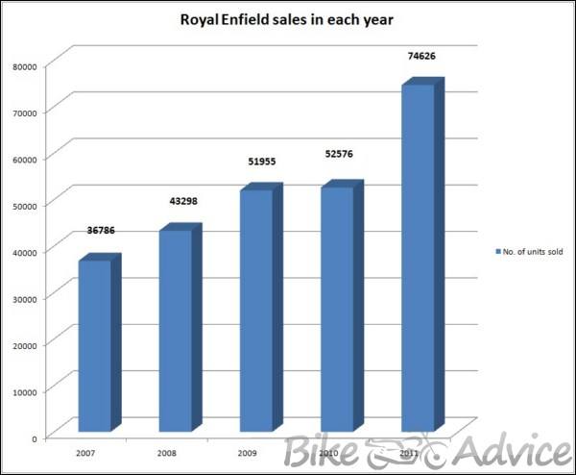

During FY16, RE sold 508,099 motorcycles which is six times of what it sold five years ago with a total market share of 96% in midsize (250cc to 750cc) motorcycles segment.

The company manufactured 462,812 units in 2015, registering a 50% growth for the three previous years consecutively. Their volumes have gone up massively ever since.

**Local Operations (Current):**

Royal Enfield currently has three manufacturing and assembly facilities in Chennai, between which the oldest was set up in 1995.

However, in the next few years, Royal Enfield had gone off the radar of its target consumer market due to an increase in prices of about 8-10% on account of a transition to BS IC emission norms, a spike in insurance cost and the introduction of a mandatory anti-lock braking system.

From a strong double-digit growth over the last five to six years, Royal Enfield has slipped into a double-digit decline in the last four months.

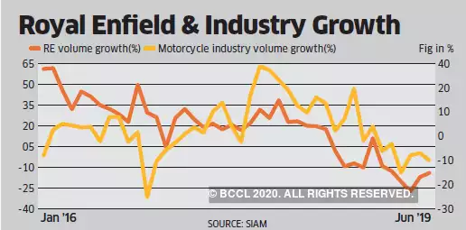

Royal Enfield had one of the highest operating profits among automakers due to its ability of being able to pass on higher costs to its customers with ease. However, the moderation in volumes over the 2018-2019 period suggests that the customers’ ability to buy at any price point is gradually waning and the rising product prices is emerging as a deterrent to convert enquiries into sales. The company’s values grew only 0.6% the previous fiscal year, its lowest volume growth since 2010.

Between April-October 2019, the sales dropped by over 20% to 3,94,760 motorcycles in the domestic market. During the same months last year, the company had sold 4,94,849 units.

Volumes declined 19 per cent to 2.37 lakh units in the first four months of FY20.

Royal Enfield operates through 12 company-operated stores, has placed 932 large-format stores in the country and has started exports to 50 countries with a major presence in USA, Australia, Argentina, UK, Italy, Japan, Germany, France, Brazil, Canada, Korea, Malaysia, Russia, Singapore to name a few.

**Business Model:**

Royal Enfield’s business model can be termed as a breakthrough emerging market business model with following characteristics: It has evolved with 50+ years of experience in automotive space in India; pivoted on in-depth understanding of market and customer insights; optimal utilization of capital through frugal engineering practices; extensive knowledge of suppliers; operational excellence and global quality standards; efficient supply chain delivering high value to its customers.

They place a high emphasis on research and development, having invested around ₹800 crore on two new R&D centres in FY2016-17. One in Leicestershire, UK and the other in Chennai.

Possible threats to business:

* Government policies: Dependence on government norms
* Rising fuel prices
* Cost structure: Enfield have a weak cost structure in comparison to their competitors.
* Lack of scale: Cost per unit of output is very high.
* International competition: Faces fierce competition internationally as well as domestically from similar brands such as Harley Davidson.
* Mature markets: Mature markets are competitive and notoriously hard to grow in. For Enfield to do that, it must increase its market share, which could cost them.
* Rising cost of raw materials.

**Advertising and Marketing Strategies:**

In India, after collaborating with Madras Motors it started building motorbikes for army men. With time, the motorcycles captured the overall market. Aesthetics being a key feature, they focused on making the design as alluring as possible.

Enfield is one of the oldest bike manufacturers in the country. It has a centuries-old heritage. Its products are targeted at the middle-aged to younger generation, who have an understand motorcycles and wouldn’t hesitate to buy, whatever the price may be.

*Campaigns*: In 2010, Royal Enfield had launched a campaign to promote its Thunderbird series. The campaign was called ‘Leave Home’ in order to encourage the Indian youth to step outside.

Weiden+Kennedy Delhi had created these print campaigns. The campaign was launched as a series of short stories among which three were titled a “Case Study, A hero Story, and Screenshot”. These comic looking leaflets were intended to inspire people to go on road trips and have fun. The company also came up with the second edition of the same type.

Collaborating with the creative agency, Weiden+Kennedy India for the second time, Royal Enfield had launched a new ad campaign which promoted protective riding gear manufactured by the same company. The campaign intended to deliver the benefits of Royal Enfield’s protective gear in order to boost the confidence of the rider so they would push their limits and explore the world. The gear was stuffed with safety features to fit all climates.

**Conclusion**

In conclusion, strong and passionate leadership has been critical to the successful establishment and growth of Royal Enfield, with clear vision and strong wills to make bold decisions which reinvent the company. This has been further cemented with strong business strategies. Though currently, the condition of the economy and market do not favour the company as much and has caused a decline in sales and net revenue; the investments made towards it, both in terms of effort and financial, are for its long-term success rather than the short-term.

**Bibliography**

* [www.economictimes.indiatimes.com](http://www.economictimes.indiatimes.com)
* [www.businessworld.in](http://www.businessworld.in)
* <http://en.wikipedia.org>
* <http://www.forbes.in>
* [www.businessinsider.in](http://www.businessinsider.in)
* [www.timesofindia.indiatimes.com](http://www.timesofindia.indiatimes.com)

**Yamaha Motor - Case Study**

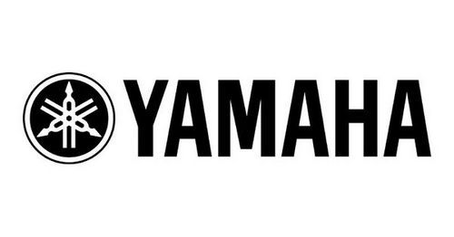

**INTRODUCTION**

Yamaha Motor Company Limited is a Japanese manufacturer of motorbikes, two-wheeler scooters, motor bicycles, four-wheeler ATVs, sailboats, boats, golf carts, water pumps and electrical generators. Yamaha Motor Company produces and deals in a wide and diversified range of products. Yamaha Motor Company was found in July 1955 by its founding father and first President Genichi Kawakami.

Yamaha made its initial foray into India in 1985.Subsequently, it entered into a 50:50 joint-venture with the Escorts Group in 1996.However, in August 2001, Yamaha acquired its remaining stake becoming a 100% subsidiary of Yamaha Motor Co., Ltd, Japan (YMC). In 2008, Mitsui & Co., Ltd. entered into an agreement with YMC to become a joint investor in the motorcycle manufacturing company “India Yamaha Motor Private Limited (IYM)”.

IYM operates from its state-of-the-art manufacturing units at Surajpur in Uttar Pradesh and Faridabad in Haryana and produces motorcycles for both domestic and export markets. With a strong workforce of more than 2,000 employees, IYM is highly customer-driven and has a countrywide network of over 400 dealers.

**VISION**

To establish YAMAHA as the “exclusive & trusted brand” of customers by “creating Kando” (touching their hearts) – the first time and every time with world class products & services delivered by people having “passion for customers”.

**BUSINESS POLICY**

* **Customer #1**

We put customers first in everything we do. We take decisions keeping the customer in mind.

* **Challenging Spirit**

We strive for excellence in everything we do and in the quality of goods & services we provide. We work hard to achieve what we commit & achieve results faster than our competitors and we never give up.

* **Teamwork**

We work cohesively with our colleagues as a multi-cultural team built on trust, respect, understanding & mutual co-operation. Everyone's contribution is equally important for our success.

* **Frank & Fair Organization**

We are honest, sincere, open minded, fair & transparent in our dealings. We actively listen to others and participate in healthy & frank discussions to achieve the organization's goals.

**BUSINESS STRATEGY**

For a long time till 2007-08, Yamaha has been following the cost control strategy by focusing on the low end 100cc bikes like Crux and Alba. This kept it market share to below 5%. In lieu of the growing Indian economy and the need for differentiator products, Yamaha revamped its strategy and shifted its focus to premium bikes. It launched R15 and FZ 150 in the 150cc segment in India.

It plans to gain 20% market share in the premium segment. The 100cc bikes are supplied only if there is a pull, but the company has clearly indicated that it sees its future in the mid-market and premium segments. The company is not just willing to limit itself to just prestige pricing. It will provide more value to the customer in terms of attributes like great technology, superior design, ergonomics for long distance travelling etc. For example, the company will be launching its new superbike FZ1- which is in the 1000cc segment. Apart from this, it is also optimistic about the FZ-16 series it has launched in the mid-market segment (150 cc) bikes. So hence, we can see that the aim is to provide niche products for the diverse customer segments.

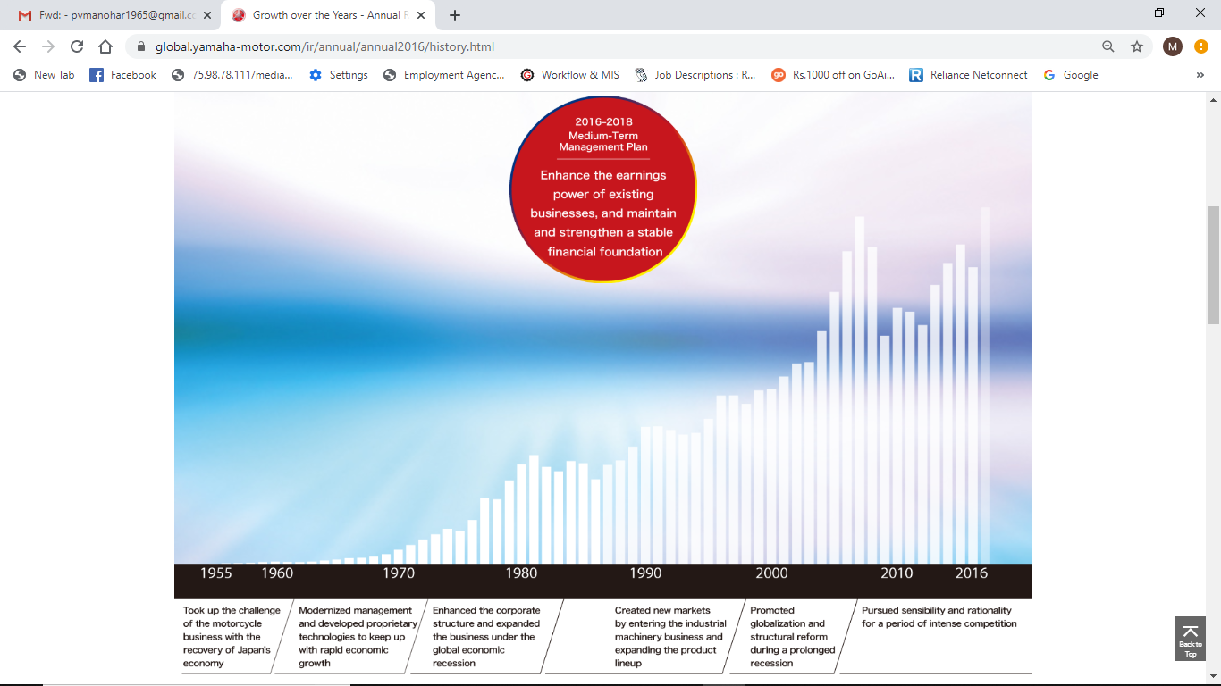

* **Foray into the rural markets**

The rural market accounts for 70% of the sales of the motorcycle industry. An extensive dealer network would be set up to finance and educate the rural customers. The National Business Head, Mr. Pankaj Dubey, cited, “We have come up with a new initiative called ‘Yamaha Bike Corner'(YBC) to reach out to customers in rural and semi-urban areas. We will open 249 more YBC by the end of this fiscal,” he said.

“We are also focusing on our ‘Yes Yamaha’ strategy to give — Yes products, yes partners and Yes promotion to realize our goals. Getting customer smile at Yamaha is the key strategy,” he said

Many bikes in the standard segment like the Crux and the YBR-110 are having a strong demand in the rural market and are crucial for the company to expand its market share,

whereas the premium segment which is still in a nascent stage is crucial for the company to expand its bottom-line.

**MARKETING AND ADVERTISING STRATEGIES**

Yamaha employs the competitive price strategy on its products. This is not at the expense of quality. In fact, Yamaha products have the best price to performance ratios in the world. Product price difference is based on the product’s power and type. Together with the pricing, some special financing options are offered thus psyching up people to buy Yamaha.

Yamaha is involved in corporate missions where it strives to ensure that the society is emotionally moved and touched by its CSR activities.

* **MARKETING STRATEGIES THAT HELPED YAMAHA SUCCEED IN INDIA**

Advertising has proved to be the best medium for any brand or product to connect itself to the millions of people.

Yamaha has used this policy in India with all its innovative skills and it always came up with “Right product at Right time” which has been so alluring to the millennial.

The Successful tagline of Yamaha

Yes Yamaha, ‘Touching your heart’- This has been one of the most famous taglines as it resonates very well with the brand image. The tagline promises the best for people and targeting supreme safety for every human by making its bike exciting & sporty. This bang on tagline even gave a tough competition to brands like Hero Honda & Bajaj.

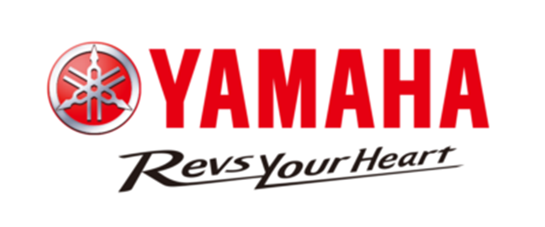

Yamaha came up with this new slogan in March 2013 basically to share the ideals of Yamaha motor group worldwide both internally & externally. It also gave a strong brand statement “Empowered by a passion for innovation, we create exceptional value & experiences that enrich the lives of our customers”. Through this tagline, Yamaha even promises to move forward to make its best in craftsmanship & marketing sector that will fulfill the expectations of the customer across the globe.

Yamaha’s marketing expresses itself as an exciting, sporty & stylish experience. This has helped the company generate high sales. Yamaha focuses on on-ground activities, digital & 00H by covering major cities such as Delhi Chennai, Kolkata, Hyderabad, and Bangalore.

**SHORTCOMINGS**

* **Marketing & Advertising**

Yamaha is a star in the BCG Matrix, it needs to have huge expenditure where Marketing and Advertising is concerned. However, compared to other brands like Hero or others, Yamaha does not use television as effectively though it is present in Top magazines and regularly found in the newspaper. A lot more is expected from a brand like Yamaha in terms of Advertising.

* **Distribution**

Another problem which is faced especially in developing countries where Yamaha is present is that the distribution is not up to mark. Even in India, the distribution is quite low and does not match with other prominent motorcycle brands like Honda, Bajaj, Hero or others.

* **Service**

Because the distribution points are less, the service points are less as well. Hence a customer thinks of the service convenience before buying this product and might not purchase the bike itself. Therefore, along with sales distribution, service points distribution is also needed. This is probably the weakest point in the SWOT analysis of Yamaha.

* **Sales is dropping**

As per this graph by Statista, the sales of Yamaha are dropping year on year and 2016 is when it has dropped the most.

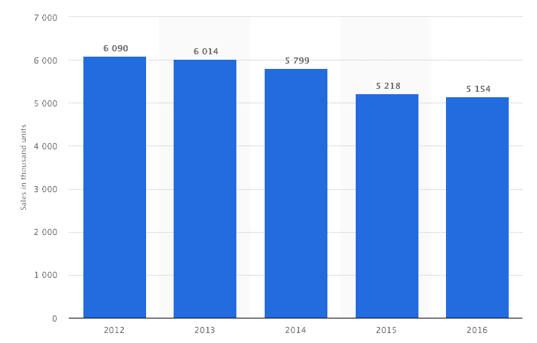

2017 2018

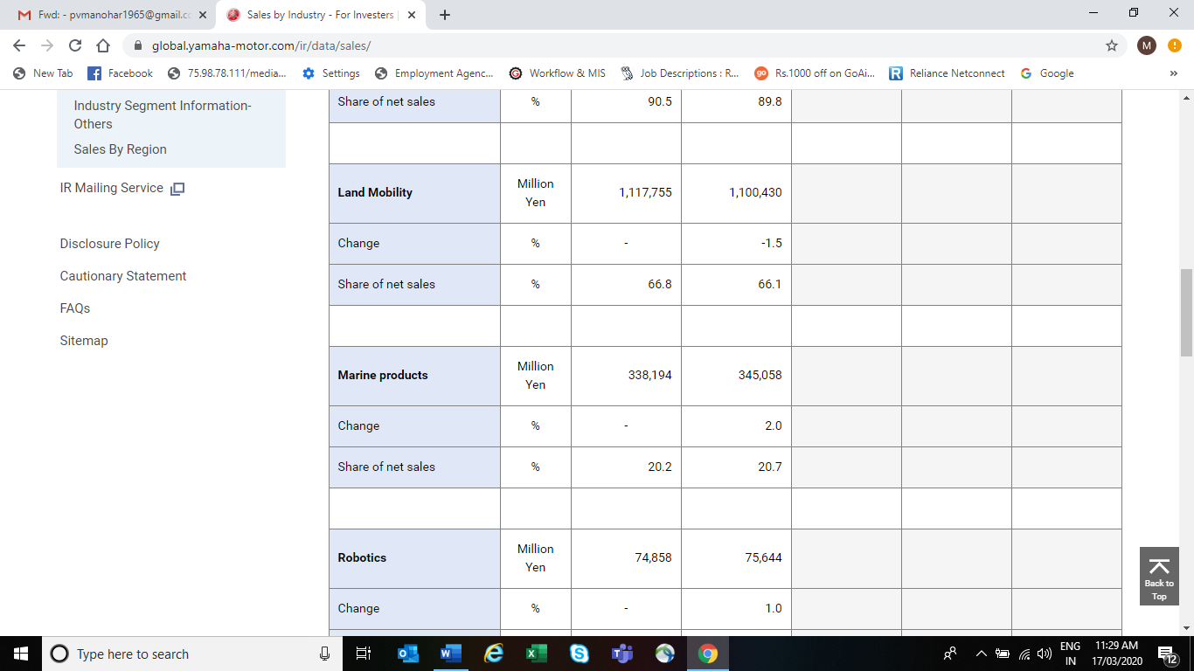

**FUTURE PLANS TO BOOST ECONOMIC GROWTH**

* **Electric Bikes**

Yamaha is already into Electric bikes and this is a product for the future. As more and more people move onto electric cars, bikes will not be left far behind and already the adoption has started in many regions. Regions which are environmentally conscious have made electric bikes mandatory because of the low carbon footprint.

* **Low tier segment motorcycles**

Most of Yamaha’s products are positioned as premium whereas Yamaha should be looking at the low tier as well as mid-tier segments. Brands like Volkswagen in cars have proved that a single company can cater to all segments even if it does the same with different brands. With the same concept, Yamaha can concentrate on the low tier and mid-tier segment to have a huge boost to its dropping sales.

* **Distribution**

Having more distribution point and service points are required by the brand. It is a weakness which Yamaha has and covering that weakness can mean an opportunity for the brand.

* **Brand driver products**

Like Pulsar in Bajaj or Splendor and Passion in Honda, Yamaha needs products which are the drivers for its brand. A single product or 2 products which are the main products advertised by the brand and which can penetrate the market yet build brand equity, such products need to be marketed by Yamaha.

* **Rising Disposable income & Emerging markets**

Yamaha plans to especially target nations where the GDP is rising and there is more and more disposable income. Such markets will always first prefer bikes and then will move on to cars. Yamaha needs to cover these regions to increase overall sales.

**CONCLUSION**

Yamaha can be described as a prospector (especially after the year 2007) as it has been constantly trying to explore new markets and opportunities. It provides bikes for almost every market segment ranging from the 100cc Crux to the 1000cc FZ1.It aims at providing a diversified product range to satisfy a wide variety of customer preferences. It has come up with several innovations like improving fuel efficiency of the bikes, introducing environment friendly engines, reducing the size of the engines and introducing light weight and compact metals for its bikes.

**BIBLIOGRAPHY**

* <https://global.yamaha-motor.com>
* <https://economictimes.indiatimes.com>
* [www.forbes.in](http://www.forbes.in)
* [www.businessworld.in](http://www.businessworld.in)

**Conclusion**

ICRA expects Motorcycle domestic volumes to grow at 6-7% and two-wheeler volumes to grow at 8-10% during FY2019 driven by strong rural demand as well as expanding urban consumption. The demand recovery from rural households in recent quarters drew strength from improved farm sentiments as well as cash flows following two seasons of near normal monsoons and resultant healthy crop output. This optimism is being complemented by Government’s policies to achieve the vision to double farmers’ income by 2022 driving consumption demand from rural sector as well as an expectation of normal monsoon precipitation supported by developing la Nina conditions. Moreover, pay revision by 3-9 state governments should support urban demand. Additionally, the recovery in oil prices has resulted in higher demand from select international markets, which coupled with new markets explored by OEMs would drive exports in the current fiscal.

ACG expect that over next coming year the three-tier structure of the industry which was 20 percent for the entry-level segment, 60 percent in value for the mid-level and 20 percent at a premium level for the time and the current trend has moved to 30-50-20 percent and it is on its way to moving to 35-40-25 percent structure. This means the middle-level market is getting squeezed out, which in turn is very good for companies like, Yamaha, Bajaj, Suzuki. Hero MotoCorp, Bajaj Auto and Honda need to introduce new innovative product range in this segment since these companies are the major player of value plus segment.

